Q1. WACP to print a message on the screen.

#include<stdio.h>

int main(){

printf("Hello Ruhul");

return 0;

}

**Output Screen:**

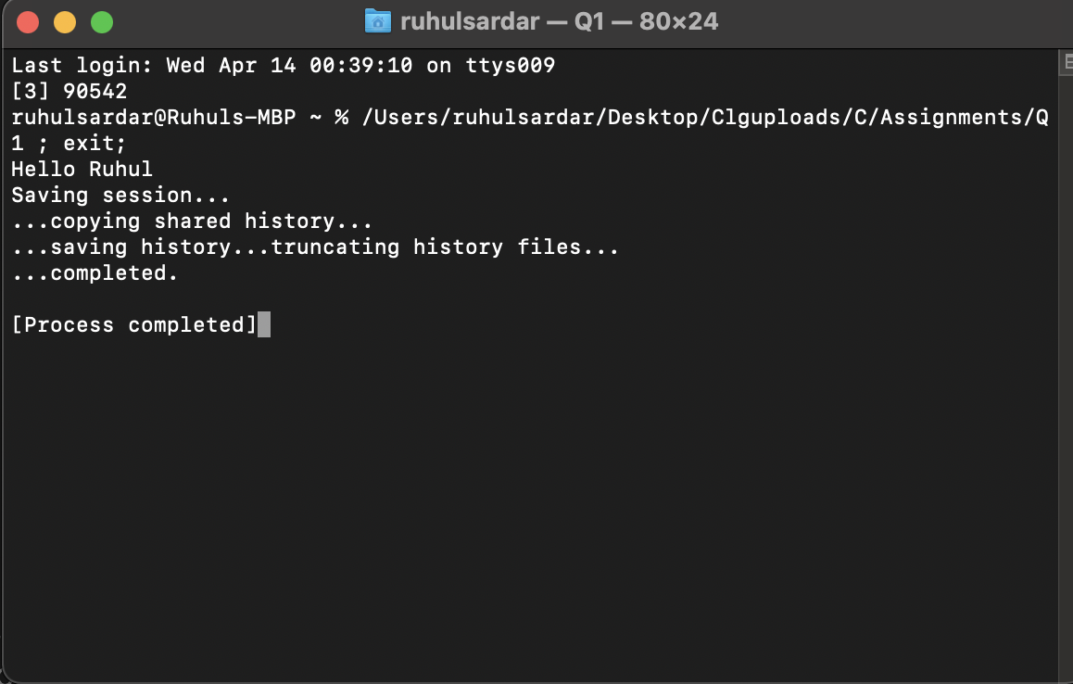

Q2. WACP to add two numbers.

#include<stdio.h>

int main(){

int a, b, c;

printf("Enter the 1st number: ");

scanf("%d", &a);

printf("Enter the 2nd number: ");

scanf("%d", &b);

c = a + b;

printf("The sum of %d and %d is %d", a,b,c);

return 0;

}

**Output Screen:**

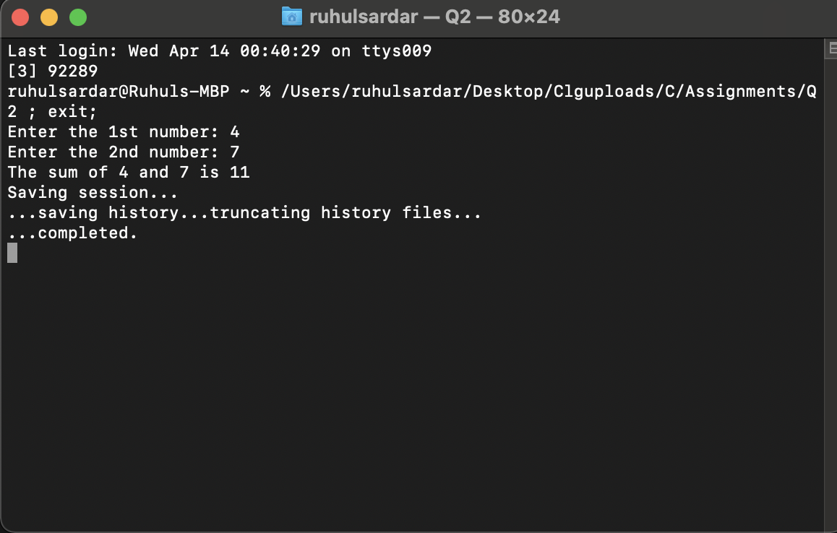

Q3. WACP to read a character and print its ASCII value.

#include <stdio.h>

int main(){

char ch;

printf("Enter any character: ");

scanf("%c", &ch);

printf("The ASCII value of %c is %d", ch, ch);

return 0;

}

**Output Screen:**

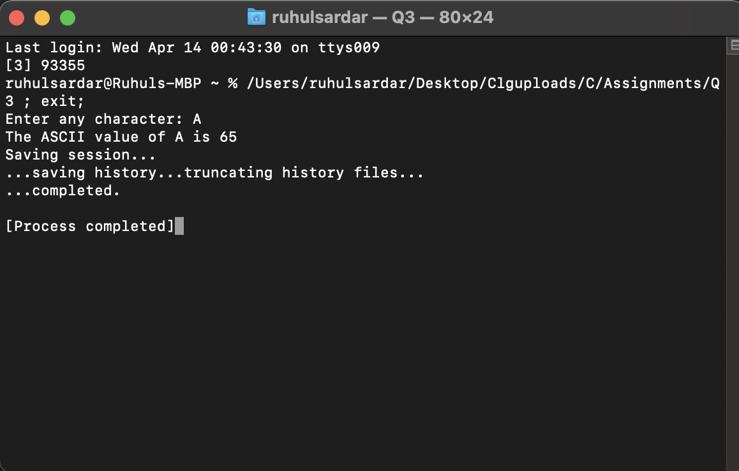

Q4. WACP to calculate simple interest.

#include <stdio.h>

int main(){

int p, t;

float r, SI;

printf("Enter the principal amount: ");

scanf("%d", &p);

printf("Enter the rate of interest: ");

scanf("%f", &r);

printf("Enter the time(years): ");

scanf("%d", &t);

SI = (p * r * t)/100;

printf("Simple interest is %f", SI);

return 0;

}

**Output Screen:**

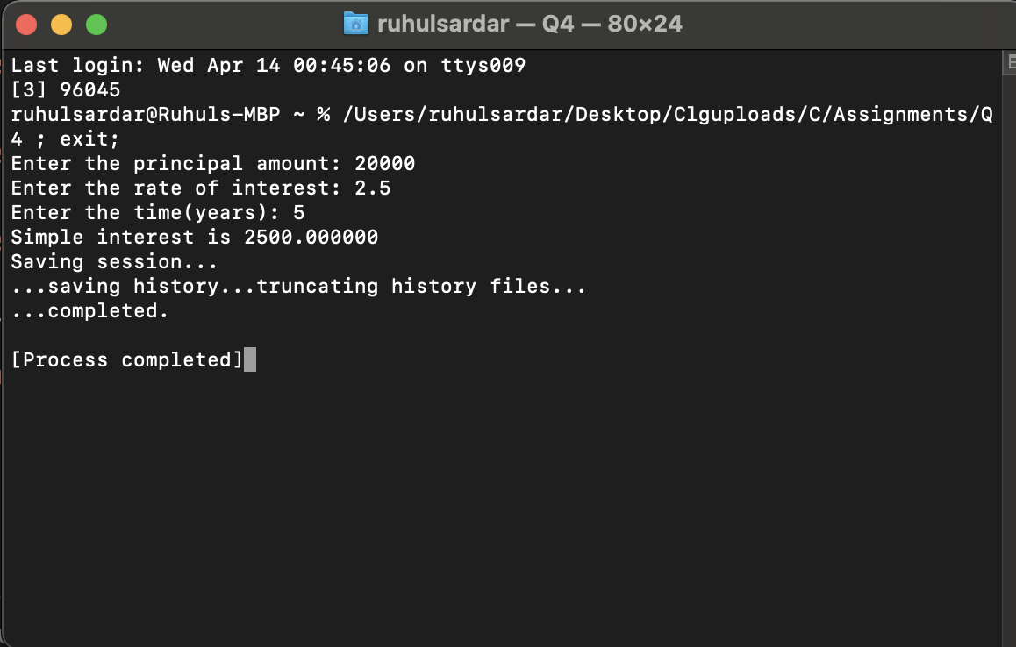

Q5. WACP to calculate compound interest.

#include<stdio.h>

#include<math.h>

int main(){

int p, n;

float r, CI;

printf("Enter the amount of principal: ");

scanf("%d", &p);

printf("Enter the time(Years): ");

scanf("%d", &n);

printf("Enter the rate of interest: ");

scanf("%f", &r);

CI = (p*(pow((1 + r/100), n) - 1 ));

printf("Amount of compund interest is: %f ", CI);

return 0;

}

**Output Screen:**

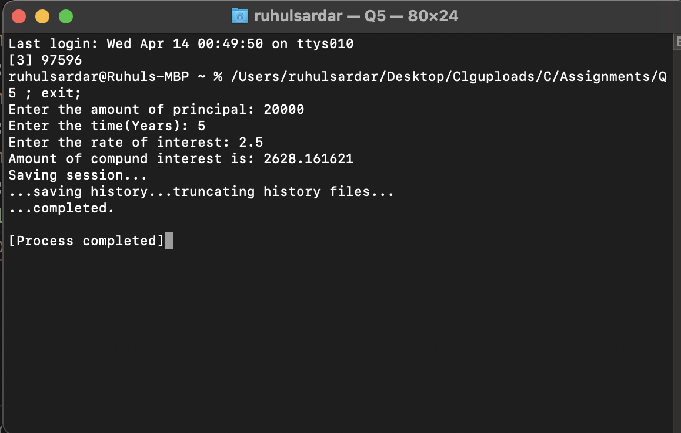

Q6. WACP to swap two integer numbers without using any 3rd variable.

#include<stdio.h>

int main(){

int a, b;

printf("Enter the value of a: ");

scanf("%d", &a);

printf("Enter the value of b: ");

scanf("%d", &b);

a = a + b;

b = a - b;

a = a - b;

printf("The swapped value of a is %d", a);

printf("\nThe swapped value of b is %d", b);

return 0;

}

**Output Screen:**

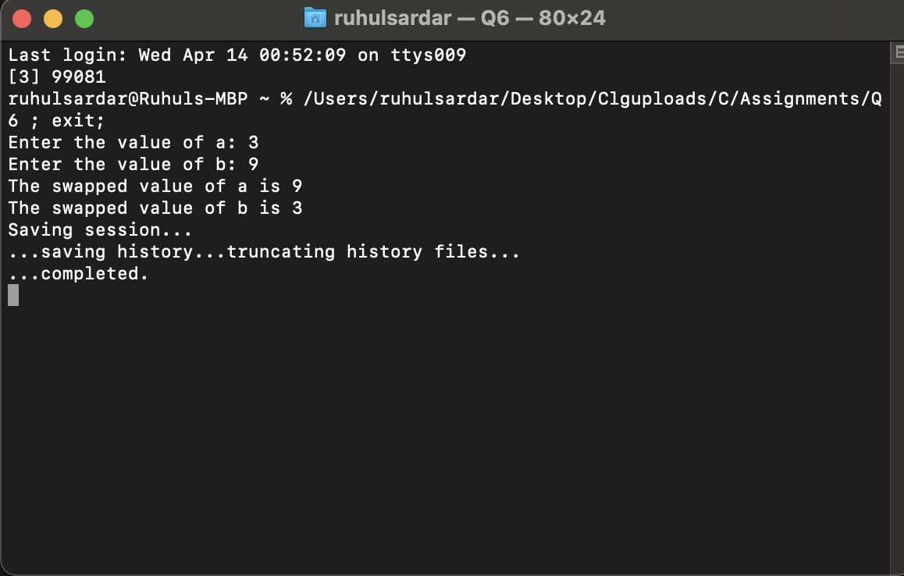

Q7. WACP to swap two integer numbers using 3rd variable.

#include<stdio.h>

int main(){

int a, b, c;

printf("Enter the value of a: ");

scanf("%d", &a);

printf("Enter the value of b: ");

scanf("%d", &b);

c = a;

a = b;

b = c;

printf("The swapped value of a is %d", a);

printf("\nThe swapped value of b is %d\n", b);

return 0;

}

**Output Screen:**

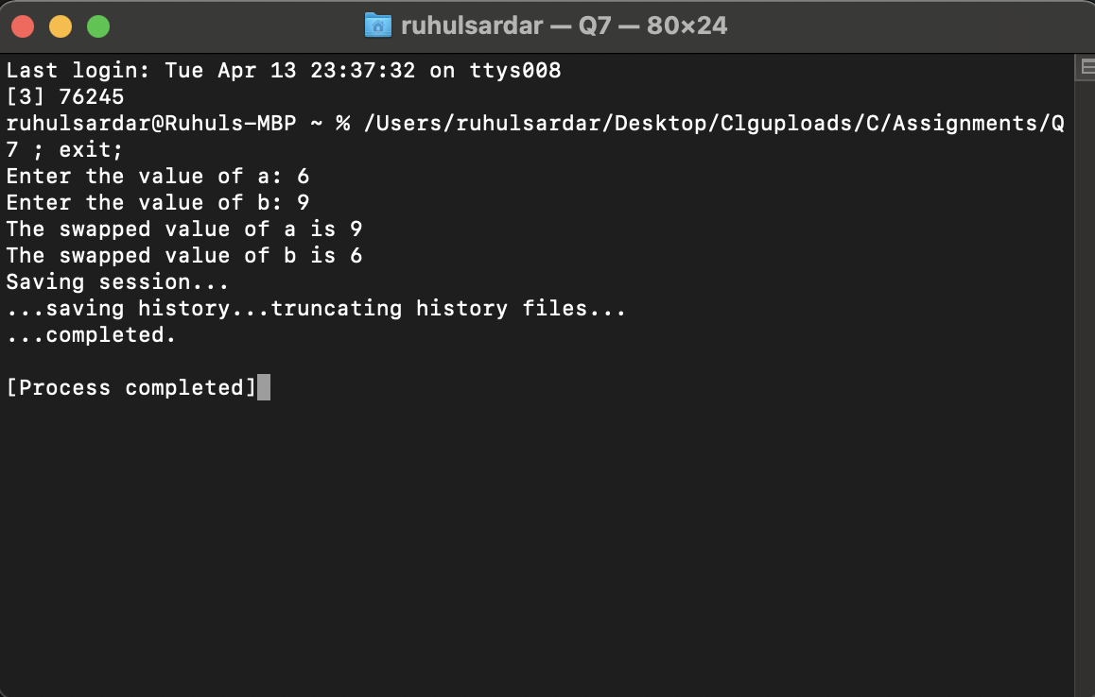

Q8. WACP to find the area and circumference of a circle.

#include <stdio.h>

#define PI 3.14

int main(){

float area, circumference;

int r;

printf("Enter the value of radius: ");

scanf("%d", &r);

circumference = 2 * PI * r;

area = PI * r * r;

printf("Circumference of the circle is : %f ", circumference);

printf("\nArea of the circle is : %f ", area);

return 0;

}

**Output Screen:**

